ADTA 5900/5750.501: Applied Natural Language Processing
Assignment 2
PART I: Request GCP Free Credit Coupon and Redeem It (10 Points)
As discussed, from the instructor’s request, Google Cloud Platform (GCP) offers a $50.00 free credit coupon to each student who can redeem and use the credit for classwork.
TO-DO
- Access the link provided in the instructor’s announcement email to request a free credit coupon.
- Redeem the free credit coupon following the instructions in GCP’s email.
- Capture the screenshot that shows “Billing Account for Education.”
SUBMISSION REQUIREMENT PART I #1:
- Submit the screenshot that shows “Billing Account for Education”
Answer:
The below screenshot shows the GCP credit is successfully redeemed.
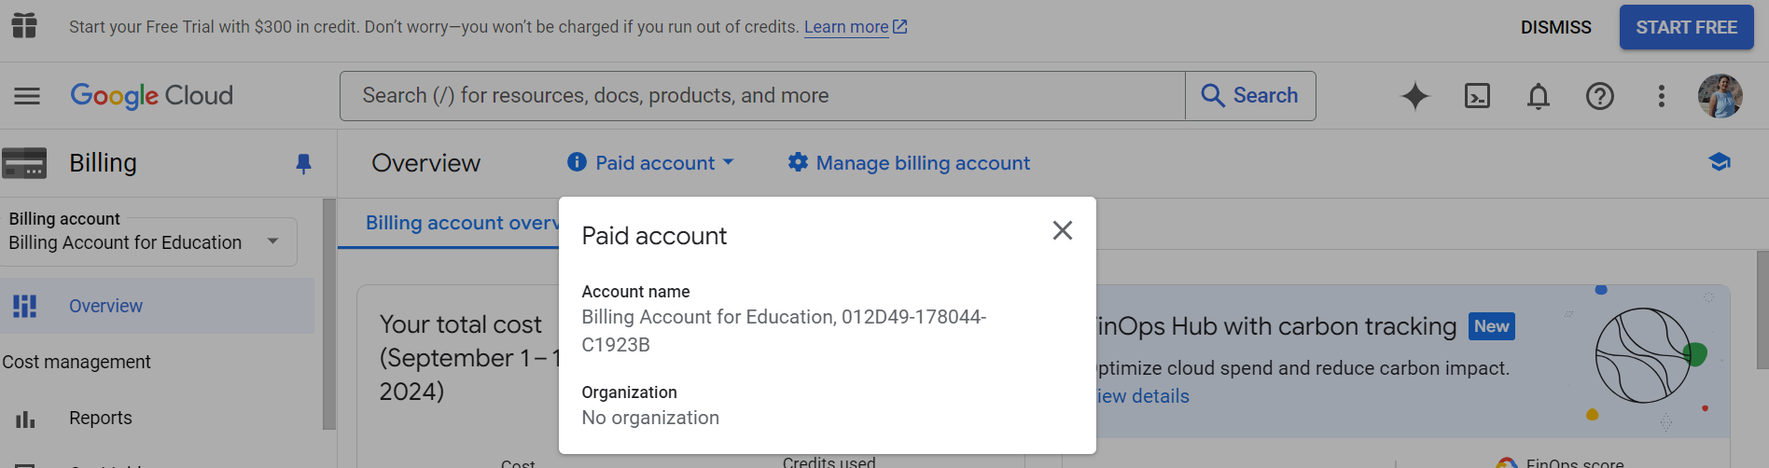
I have followed the given document “HOWTO_redeem_GCP_credit_coupons.pdf” to redeem the coupon to gain the GCP credit.

PART II: GCP: Dialogflow CX: Fundamental Concepts (20 Points)
As discussed in the lecture, in GCP: Dialogflow CX, the following concepts are used to design and manage conversation flows:
- Conversation Session, a.k.a. Conversation or Session
- Agent
- Flow
- Page
- State
- State Handler, a.k.a. Handler
- Intent
- Entity
TO-DO
- Access and read the documentation of GCP: Dialogflow CX, focusing on the above concepts.
o At this link: https://cloud.google.com/dialogflow/cx/docs
SUBMISSION REQUIREMENT PART II:
--) Write a report on what the student can learn about each concept mentioned above focusing on the following points:
- What is the concept?
- What role does the concept play in an AI Dialogue System created using Dialogflow CX?
Answer:
- Conversation Session:
Concept:
- Is a collection of all the conversations between the user and the DialogFlow CX agent for a given time frame.
- It includes all the inputs given by the user and the responses by the agent and the current state of the chat (active/inactive).
Role in AI Dialogue System:
- It maintains the state and context of the conversation. This enables the agent to efficiently manage the multi-turn chat and give responses based on the current dialog history making the conversation more meaningful.
- With the help of a unique identifier, the agent can handle multiple sessions simultaneously.
- Agent:
Concept:
- It is a virtual agent capable to handle the simultaneous conversations with users.
- It can understand details of human language as it is a natural language understanding module.
Role in AI Dialogue System:
- It effectively converts the user input (text/audio) into structured data which can be processed by the application and services.
- It can be compared to a call centre agent who can be trained to respond to preliminary customer queries but does not need be constantly monitored.
- Flow:
Concept:
- A complex conversation can have many topics, a flow is used to define such topics and like “customer details”, “order confirmation”,” payment options” etc.
- In this case there will be one flow to get the customer details, another to confirm the order and one more for payment options.

Role in AI Dialogue System:
- For every agent there is a “default start flow”.
- More complex agents may have multiple flows to handle each topic.
- The below fig shows an example for a flow.
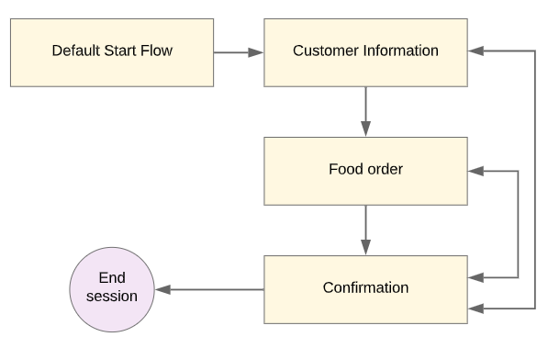
Figure: Example of flow
Source: https://cloud.google.com/dialogflow/cx/docs/basics
- Page:
Concept:
- The states of a session can be expressed as pages.
- A flow can have multiple pages, all these pages together can manage a complete flow for that given context.
Role in AI Dialogue System:
- Each page is configured to collect the required information relevant for the page.
- At any point of time, only one page can be “Active”. When the flow becomes active, the start page becomes the current page.
- For each turn in the chat, the current page will stay the same or move to another page.
- The below diagram shows “Start” represents the start page of the food order flow.
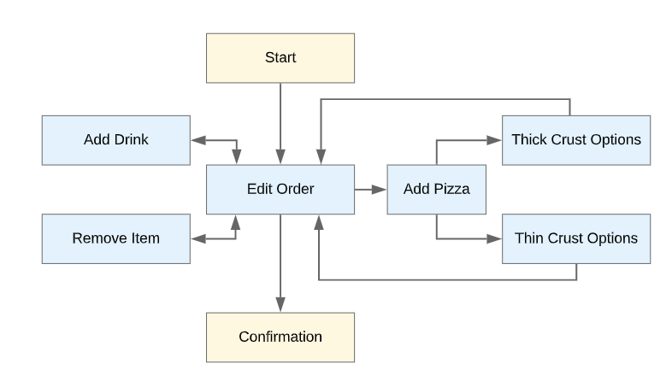
Figure: Page in food order
Source: https://cloud.google.com/dialogflow/cx/docs/basics
- State:
Concept:
- Each page represents a state in a conversation.
Role in AI Dialogue System:
- Based on the input by the user, the next state or page is decided.
- State Handler:
Concept:
- A state handler handles the conversation by generating a response for the user.
Role in AI Dialogue System:
- For every conversational turn, handers are analysed, and the state might get change accordingly.
- There are three types of data for Handlers:
  - Handler requirements: the requirements for the handler to it to come into action in a session.
  - Handler fulfilment: upon a handler being called, an optional fulfilment comes into action for generating responses for the user. These responses can be from static agent or from the webhook service.
  - Handler transition target: when the handler is called, the current page is changed by an optional transition target.

- Intent:
Concept:
- The user’s intention for a conversation turn can be categorized by an Intent.
- Intent contains the below data:
  - Display Name
  - Labels
  - Training phrases
  - Parameters
  - DTMP patterns
Role in AI Dialogue System:
- Categorization of the motive of the conversation helps the flow to generate appropriate response by engaging the relevant entity.
- When the input by the user resembles a training phrase, DialogFlow CX matches it with the intent.
- The parameters are used by the training phrases the extract a specific part from the user-input.
- Entity:
Concept:
- The data extraction from the user input is controlled based on Entity Types.
Role in AI Dialogue System:
- System Entities such as Date, time, email address etc are predefined by DialogFlow CX.
- We can define our custom entities such as fruit or vegetables for placing order with a grocery store agent.
PART III: GCP: Dialogflow CX: Create a Virtual Agent (30 Points)
Any AI conversational system created using Dialogflow CX requires at least a virtual agent (Ref: GCP: Dialogflow CX documentation).
For PART II, the following references can be used:
File: gcp_dialogflow_cx_howto_enable_API_create_agent.pdf
Documentations: GCP Dialogflow CX
TO-DO
Access and open GCP Dialogflow CX console
Enable the Dialogflow CX API and capture the screenshot showing the API has been enabled
Create a virtual agent and capture the screenshot showing the agent has been created
SUBMISSION REQUIREMENT PART III:
--) Write a report on the steps of completing the tasks with screenshots as illustrations.
Answer:
The below steps are performed to create a GCP DialogFlow CX virtual agent.
- Type “Google Cloud Dialogflow CX Console” in the search box.
- Click on the below url from the results.
  - https://dialogflow.cloud.google.com/cx/projects
- Select the project (that was created previously) and the below screen appears.
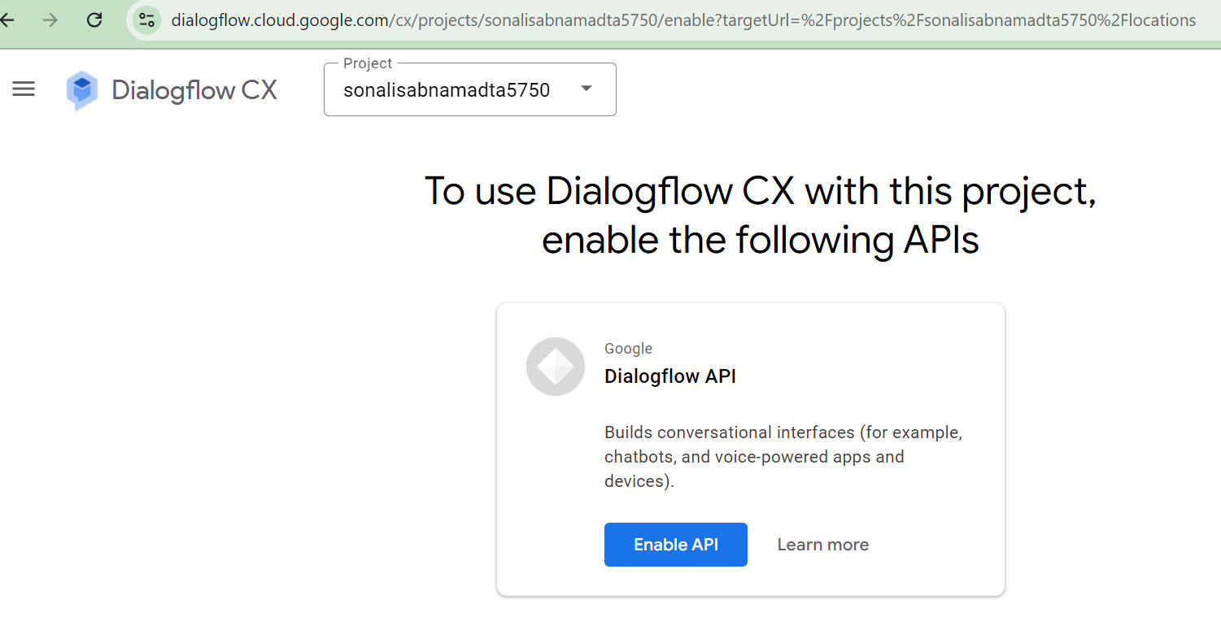
- Click on Enable API.
- The DialogFlow CX API is now enabled.
Create Dialogue Agent
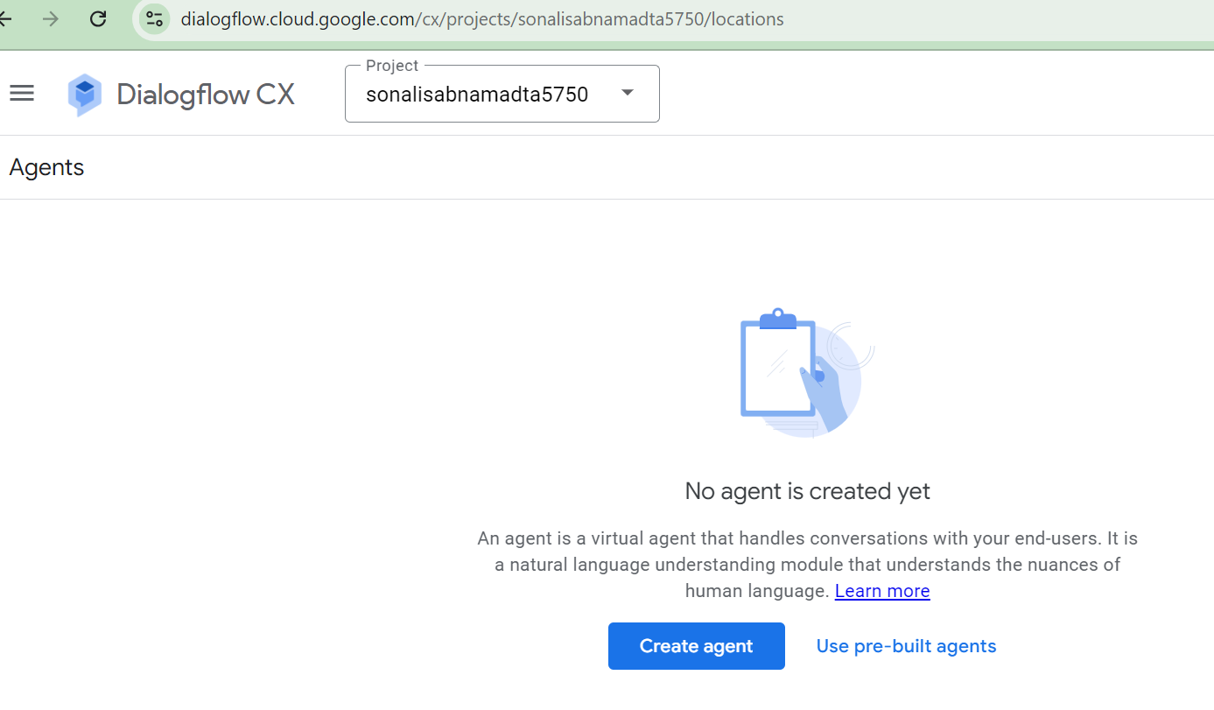
- Click on the “Create agent”.
- Provide a name for the agent, select your timezone and click on create.
- The below screen displays the agent “ADTA5750_Sonali_Agent” being created.
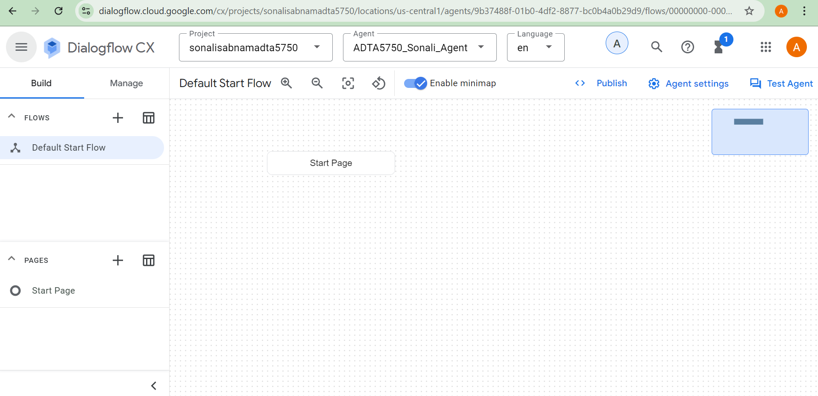
PART IV: GCP: Dialogflow CX: A Simple Conversation (40 Points)
It is assumed that a retail store named Apparel-X sells only one type of clothing: medium-size green shirts for $30.00. There is no tax on any purchase.
Customers are also assumed to know that they can buy only one type of clothing at this store. It means they do not ask about anything else.
Customer C calls the store and has the following conversation with Staff A:

A: Good morning. How can I help you?
C: Good morning. I want to buy a shirt. What color do you have?
A: It’s green.
C: Great! How much is it?
A: $30.00
C: What size?
A: Medium. Is it OK for you?
C: Yes. I like it. I’ll get to the store and buy one.
A: We’re open until 7:00 PM tonight.
C: Thanks. Bye.
A: Thank you very much. Bye.
Question 3.1:
- How many turns are there in the above conversation?
Answer: There are eleven turns in this conversation as described below. A turn is one interaction either by the agent or the customer.
- 1st turn: A: Good morning. How can I help you?
- 2nd turn: C: Good morning. I want to buy a shirt. What color do you have?
- 3rd turn: A: It’s green.
- 4th turn: C: Great! How much is it?
- 5th turn: A: $30.00
- 6th turn: C: What size?
- 7th turn: A: Medium. Is it OK for you?
- 8th turn: C: Yes. I like it. I’ll get to the store and buy one.
- 9th turn: A: We’re open until 7:00 PM tonight.
- 10th turn: C: Thanks. Bye.
- 11th turn: A: Thank you very much. Bye.

- Which turns should be included in “Default Start Flow” (See GCP: Dialogflow CX documentation)?
Answer: “Default Start Flow” handles the first few interactions and determines the context of the conversation. For the given conversation, the below mentioned part of the conversation can be set as “Default Start Flow”.
A: Good morning. How can I help you?
C: Good morning. I want to buy a shirt. What color do you have?

Question 3.2
- Following the information provided in the documentation of GCP: Dialogflow CX, design the conversation flow for the above dialogue.
- Capture a screenshot(s) for each step of the designing process to show what has been done.
- Write a report to discuss each step of designing the conversation flow in detail.
Answer: The following steps were performed to design the conversation flow of the given dialogue.
I have designed the conversation flow in GCP DialogFlow CX.
Start Page:
- Select “Default Start Flow” in the Build section and click on the “Start Page”.
- Click on “Default Welcome Intent”, the right pan opens.
- Scroll down in the right pan and click on “Fulfilment”.
- Enter the first message “Good morning. How can I help you?” in the “Agent Says” section and click on add. Click on Save.
- The below screenshot displays the fulfilment successfully defined for the default welcome intent.
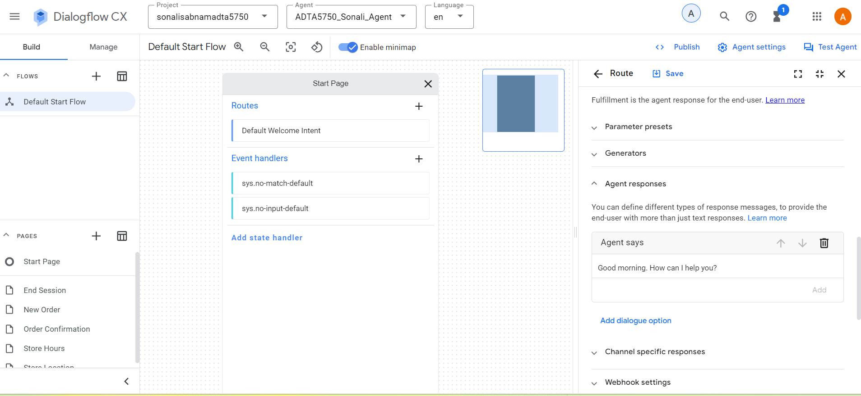
Tshirt Color Page and tshirt.color Intent:
- Click on the “+” in the Routs section in Start page. The right pane opens.
- Enter the display name as “tshirt.color”.
- Scroll down to add the training phase as “Good morning. I want to buy a shirt. What color do you have?”.

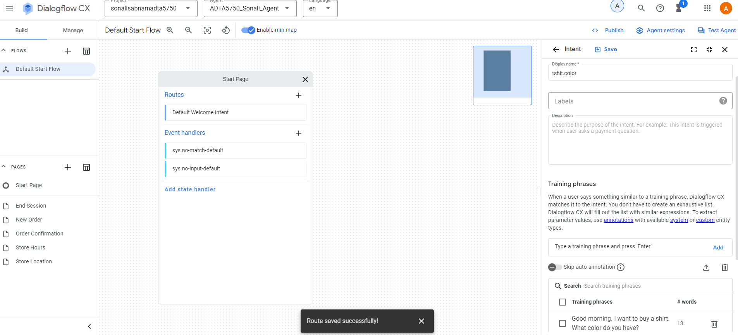
- Click on Save.
- The Route pan is now open.
- Scroll down and in Transition section select “Page”.
- Click on “New page”. Give a name to the page as “Tshirt Color” and save.
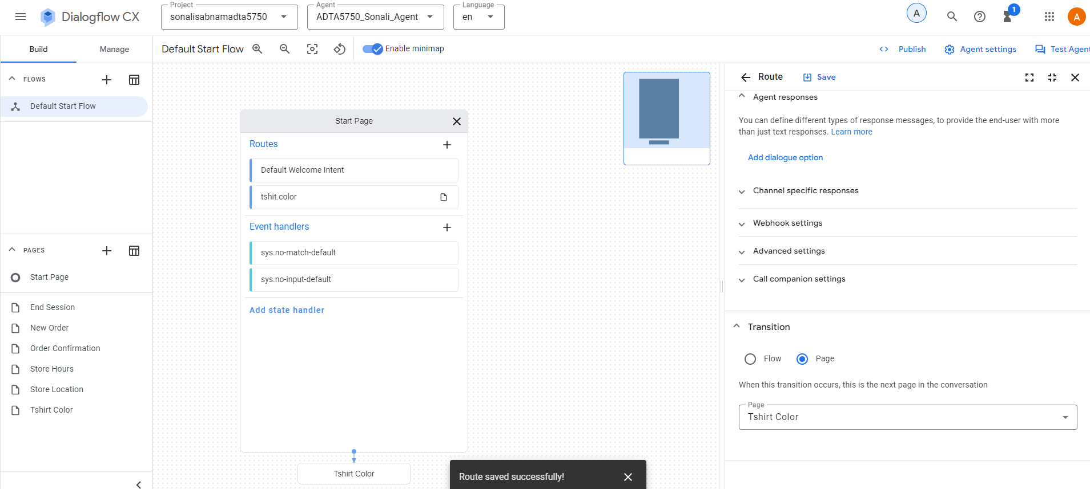
- Now the newly created page is displayed in the pages section to the left.
- Select the “Tshirt Color” page and click on Edit.
- Click on Entry Fulfilment section to add the agent response as “It’s green.”
- Click on save.
- The below screenshot displays the entry fulfilment successfully added for Tshirt Color page.
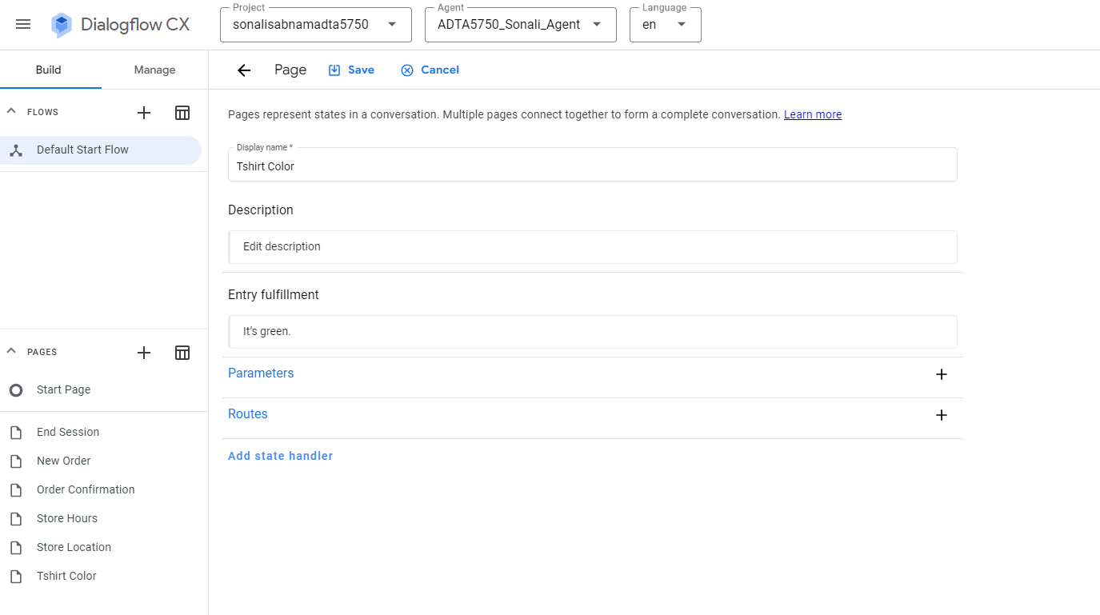
Tshirt Price Page and tshirt.price Intent:
- Click on the “+” in the Routs section in Start page. The right pane opens.
- Enter the display name as “tshirt.price”.
- Scroll down to add the training phase as “Great! How much is it?”.
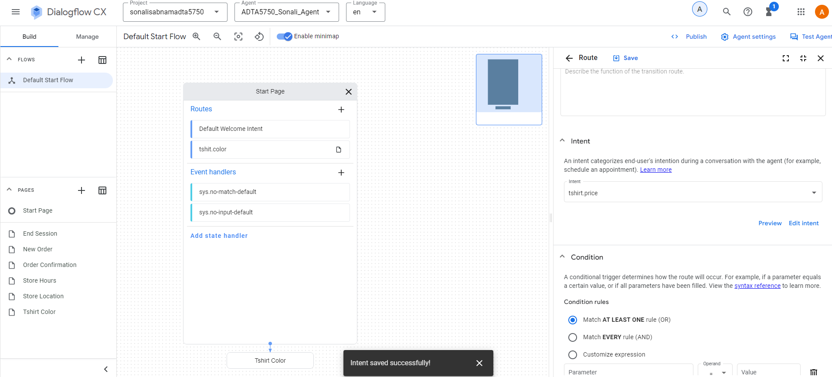
- Click on Save.
- The Route pan is now open.
- Scroll down and in Transition section select “Page”.
- Click on “New page”. Give a name to the page as “Tshirt Price” and save.
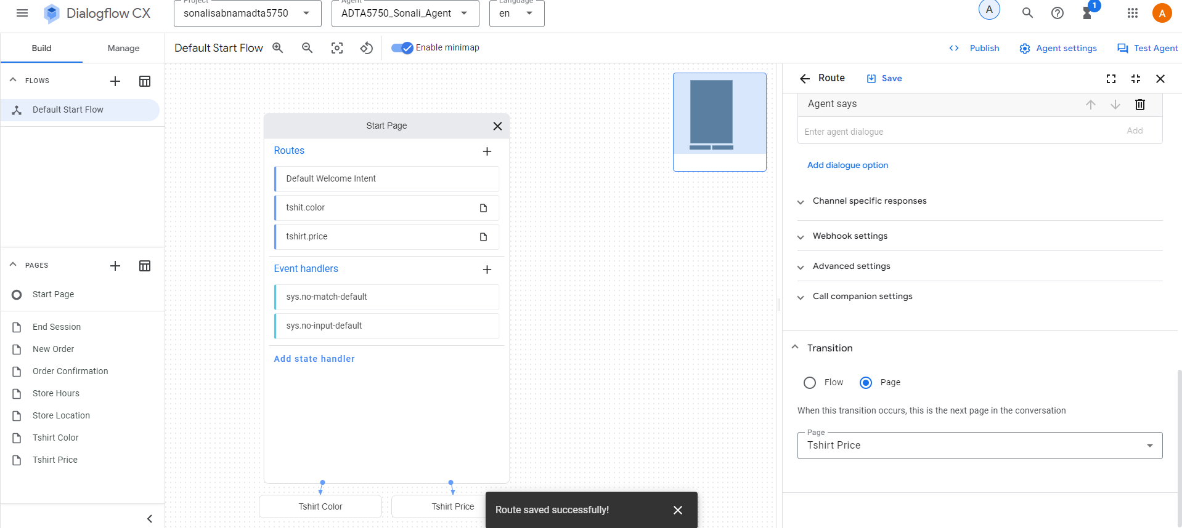
- Now the newly created page is displayed in the pages section to the left.
- Select the “Tshirt Price” page and click on Edit.
- Click on Entry Fulfilment section to add the agent response as “$30.00”
- Click on save.
- The below screenshot displays the entry fulfilment successfully added for Tshirt Price page.
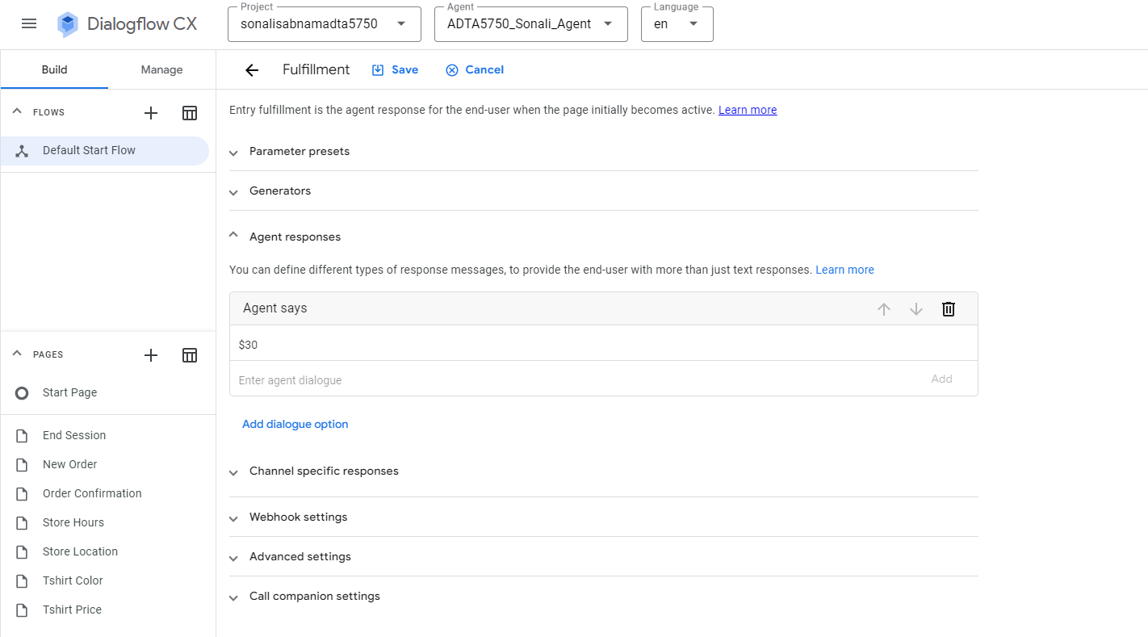
Tshirt Size Page and tshirt.size Intent:
- Click on the “+” in the Routs section in Start page. The right pane opens.
- Enter the display name as “tshirt.size”.
- Scroll down to add the training phase as “What size?”.
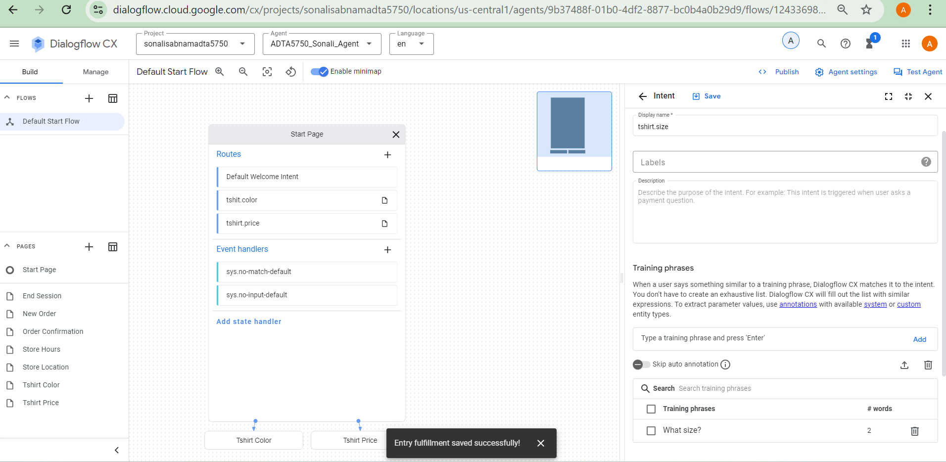
- Click on Save.
- The Route pan is now open.
- Scroll down and in Transition section select “Page”.
- Click on “New page”. Give a name to the page as “Tshirt Size” and save.
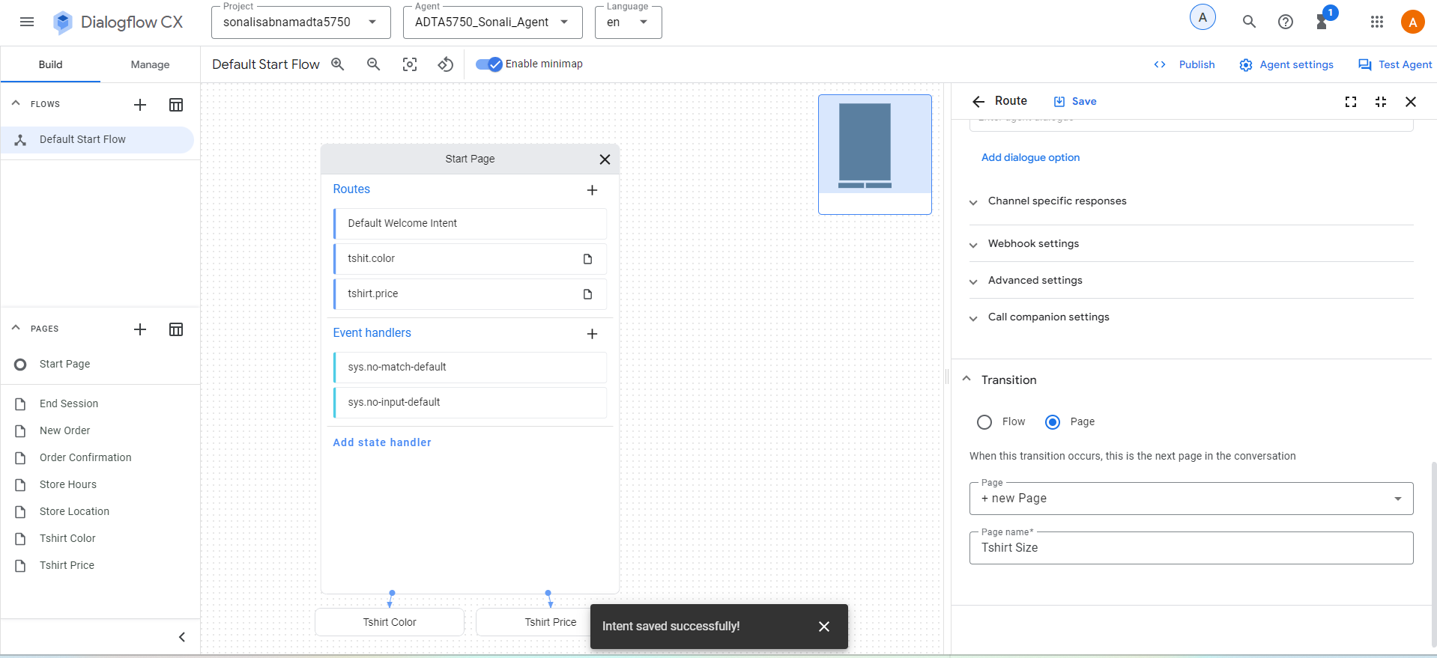
- Now the newly created page is displayed in the pages section to the left.
- Select the “Tshirt Size” page and click on Edit.
- Click on Entry Fulfilment section to add the agent response as “Medium. Is it OK for you?”
- Click on save.
- The below screenshot displays the entry fulfilment successfully added for Tshirt Size page.
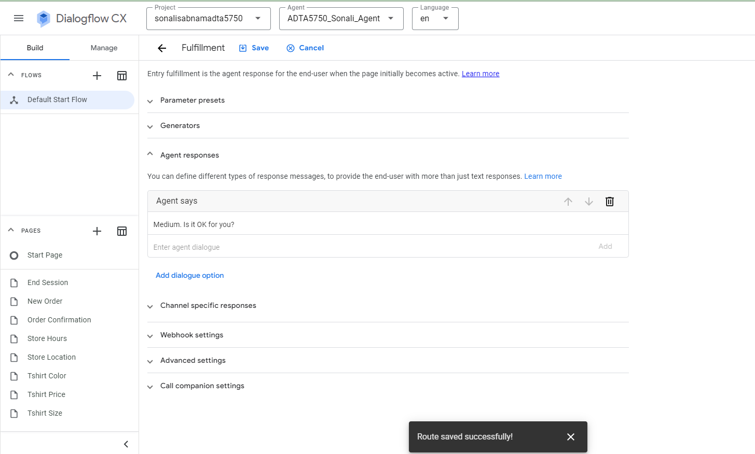

Tshirt Store Hours Page and tshirtstore.hours Intent:
- Click on the “+” in the Routs section in Start page. The right pane opens.
- Enter the display name as “tshirtstore.hours”.
- Scroll down to add the training phase as “Yes. I like it. I’ll get to the store and buy one.”.
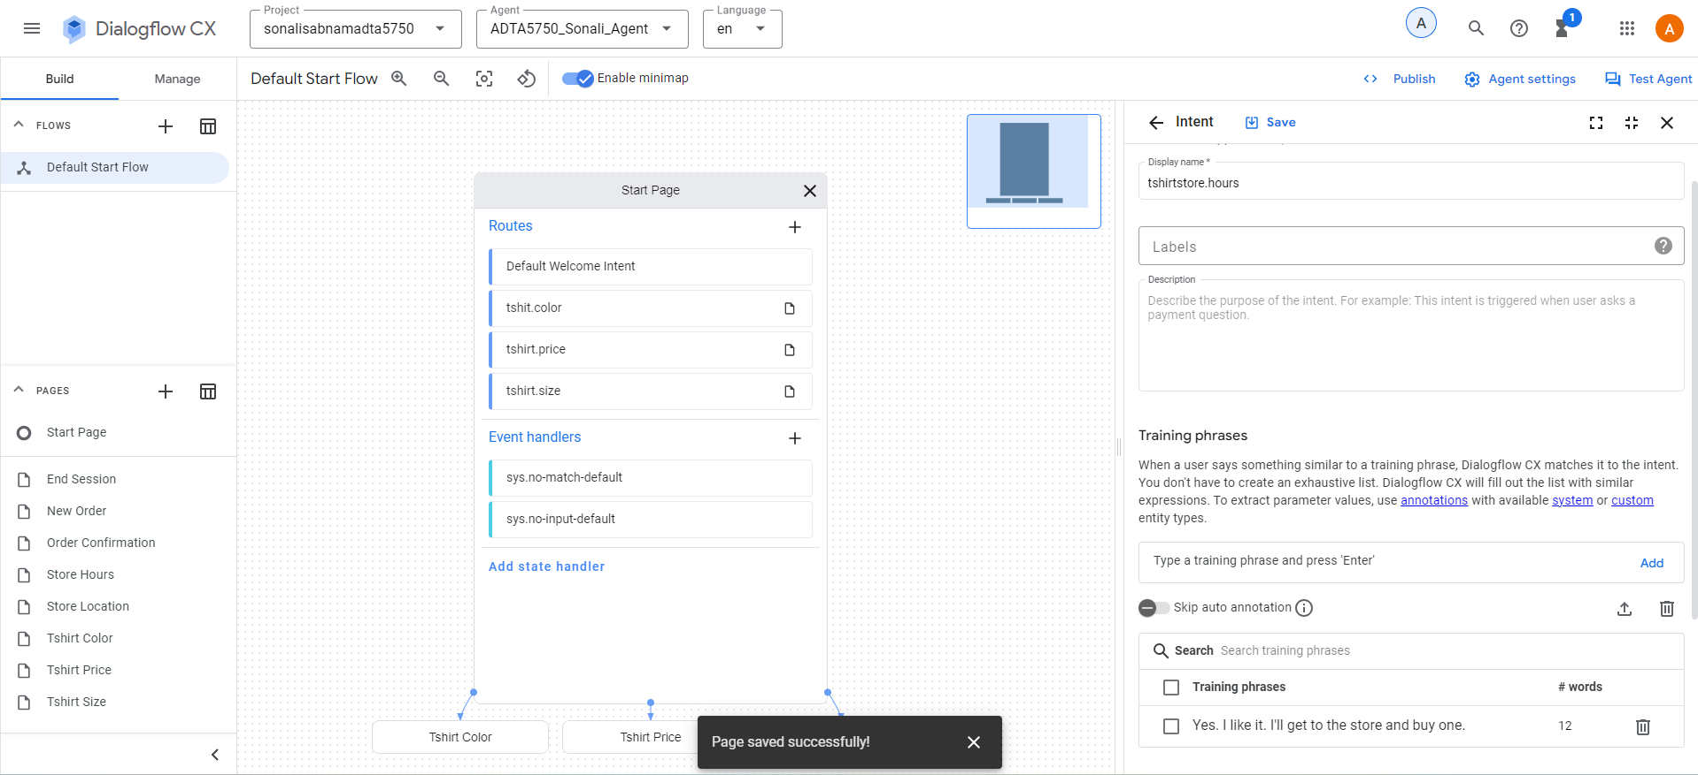
- Click on Save.
- The Route pan is now open.
- Scroll down and in Transition section select “Page”.
- Click on “New page”. Give a name to the page as “Tshirt Store Hours” and save.
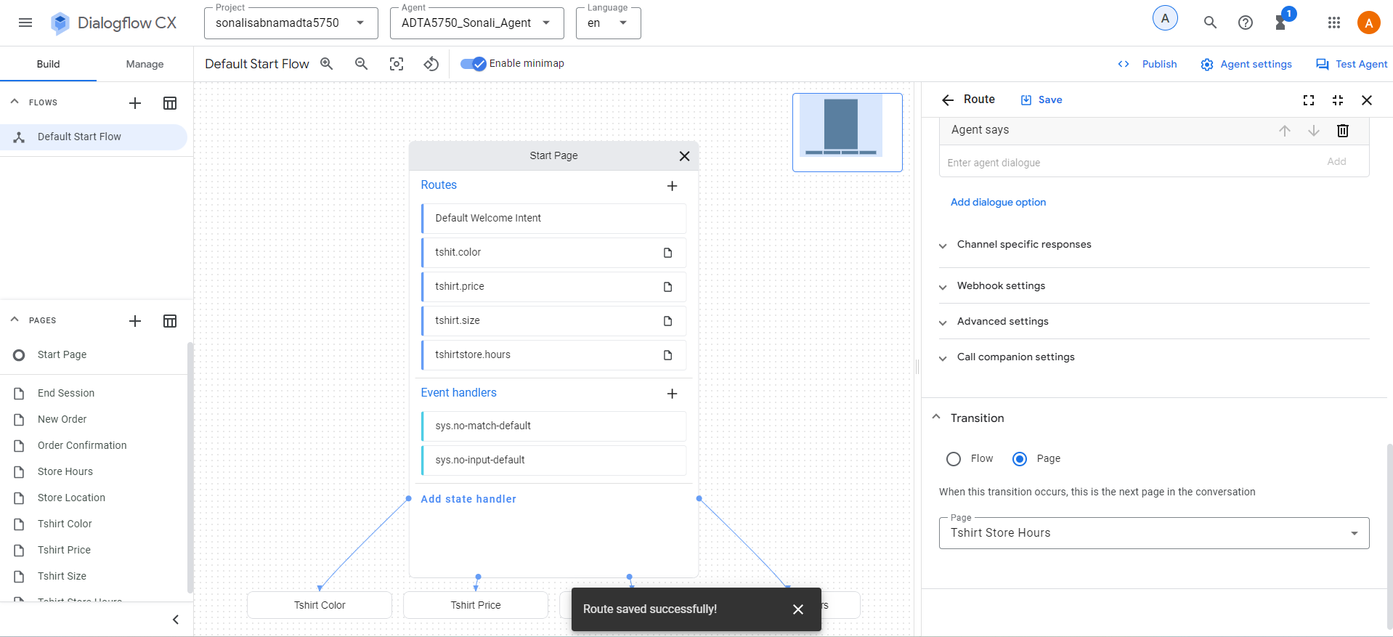
- Now the newly created page is displayed in the pages section to the left.
- Select the “Tshirt Store Hours” page and click on Edit.
- Click on Entry Fulfilment section to add the agent response as “We’re open until 7:00 PM tonight.”
- Click on save.
- The below screenshot displays the entry fulfilment successfully added for Tshirt Store Hours page.
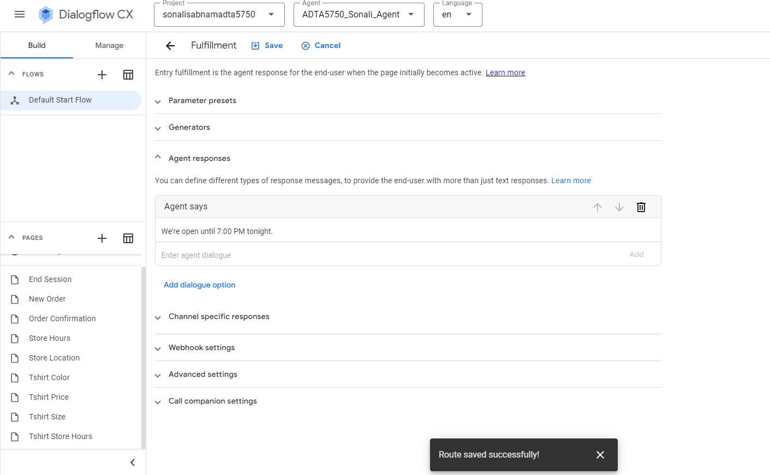
Tshirt End Session Page and tshirt.endsession Intent:
- Click on the “+” in the Routs section in Start page. The right pane opens.
- Enter the display name as “tshirt.endsession”.
- Scroll down to add the training phase as “Thanks. Bye.”.
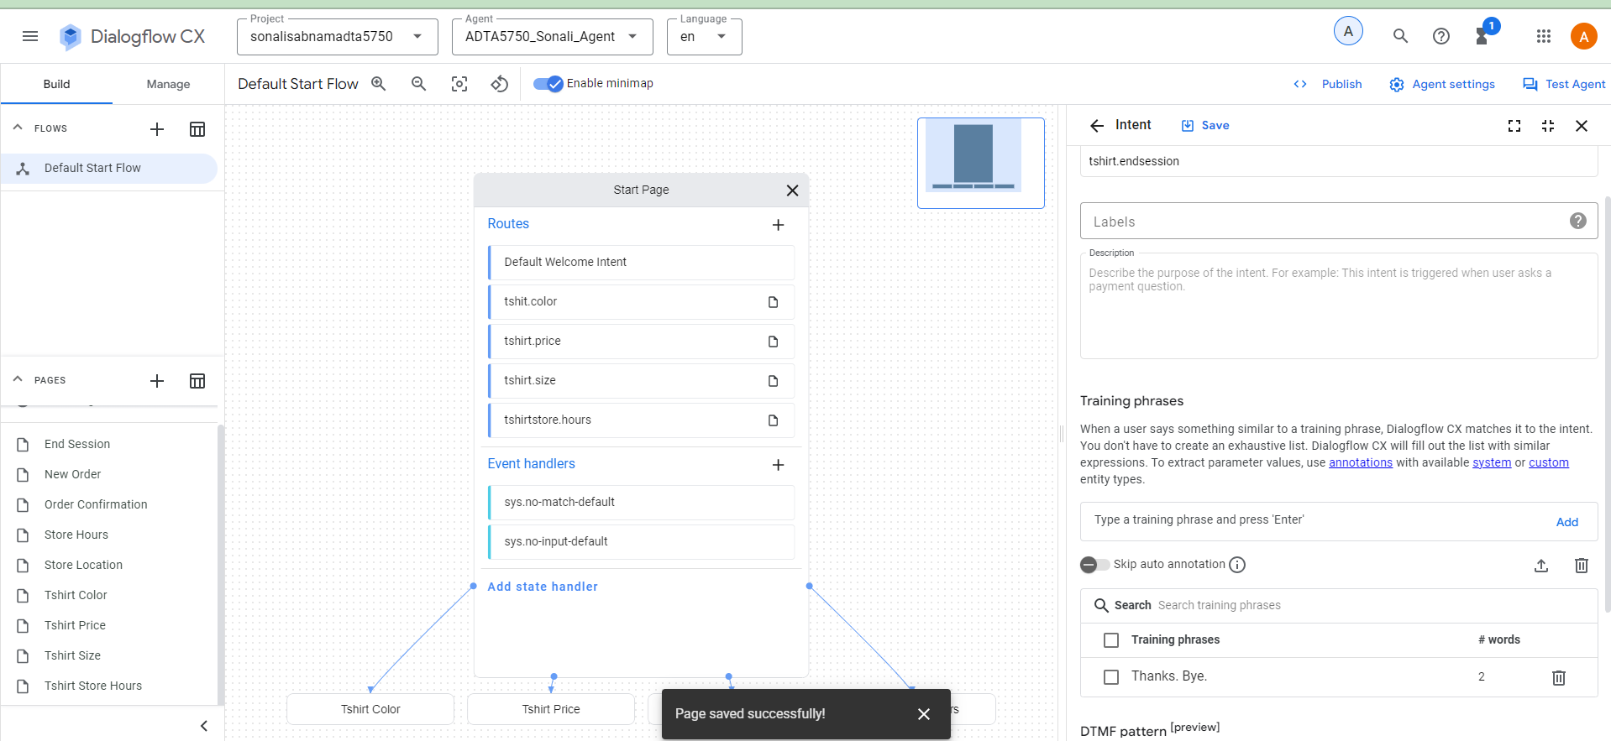
- Click on Save.
- The Route pan is now open.
- Scroll down and in Transition section select “Page”.
- Click on “New page”. Give a name to the page as “Tshirt End Session” and save.
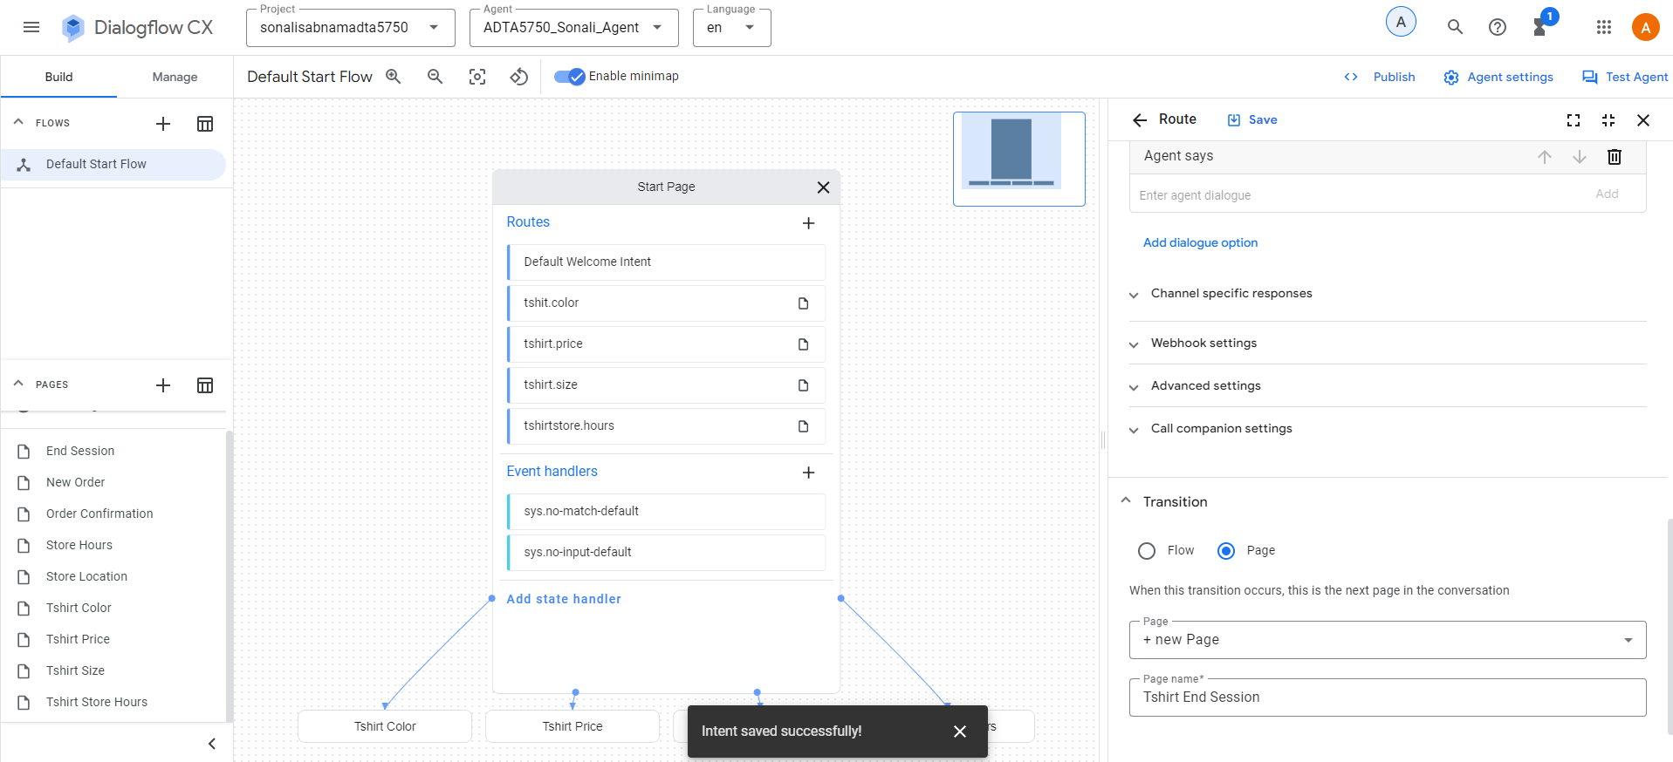
- Now the newly created page is displayed in the pages section to the left.
- Select the “Tshirt End Session” page and click on Edit.
- Click on Entry Fulfilment section to add the agent response as “Thank you very much. Bye.”
- Click on save.
- The below screenshot displays the entry fulfilment successfully added for Tshirt End Session page.
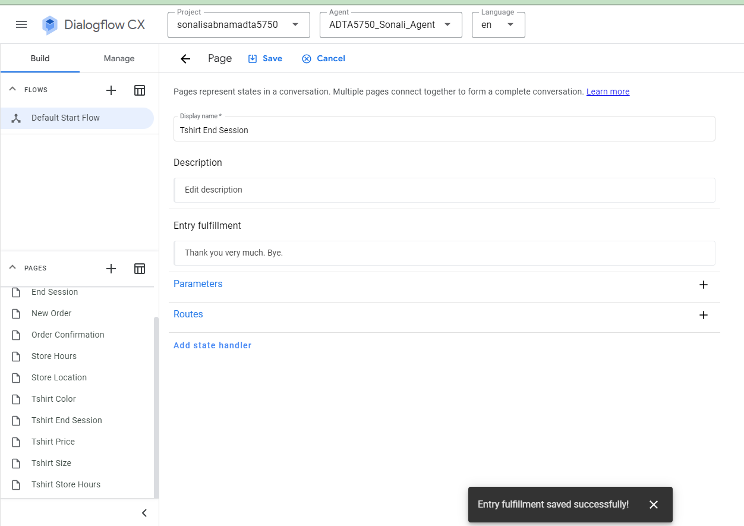
Testing the chatbot using the “Test Agent” simulator.
The below screenshot shows that the chatbot is able the respond to the user as required.
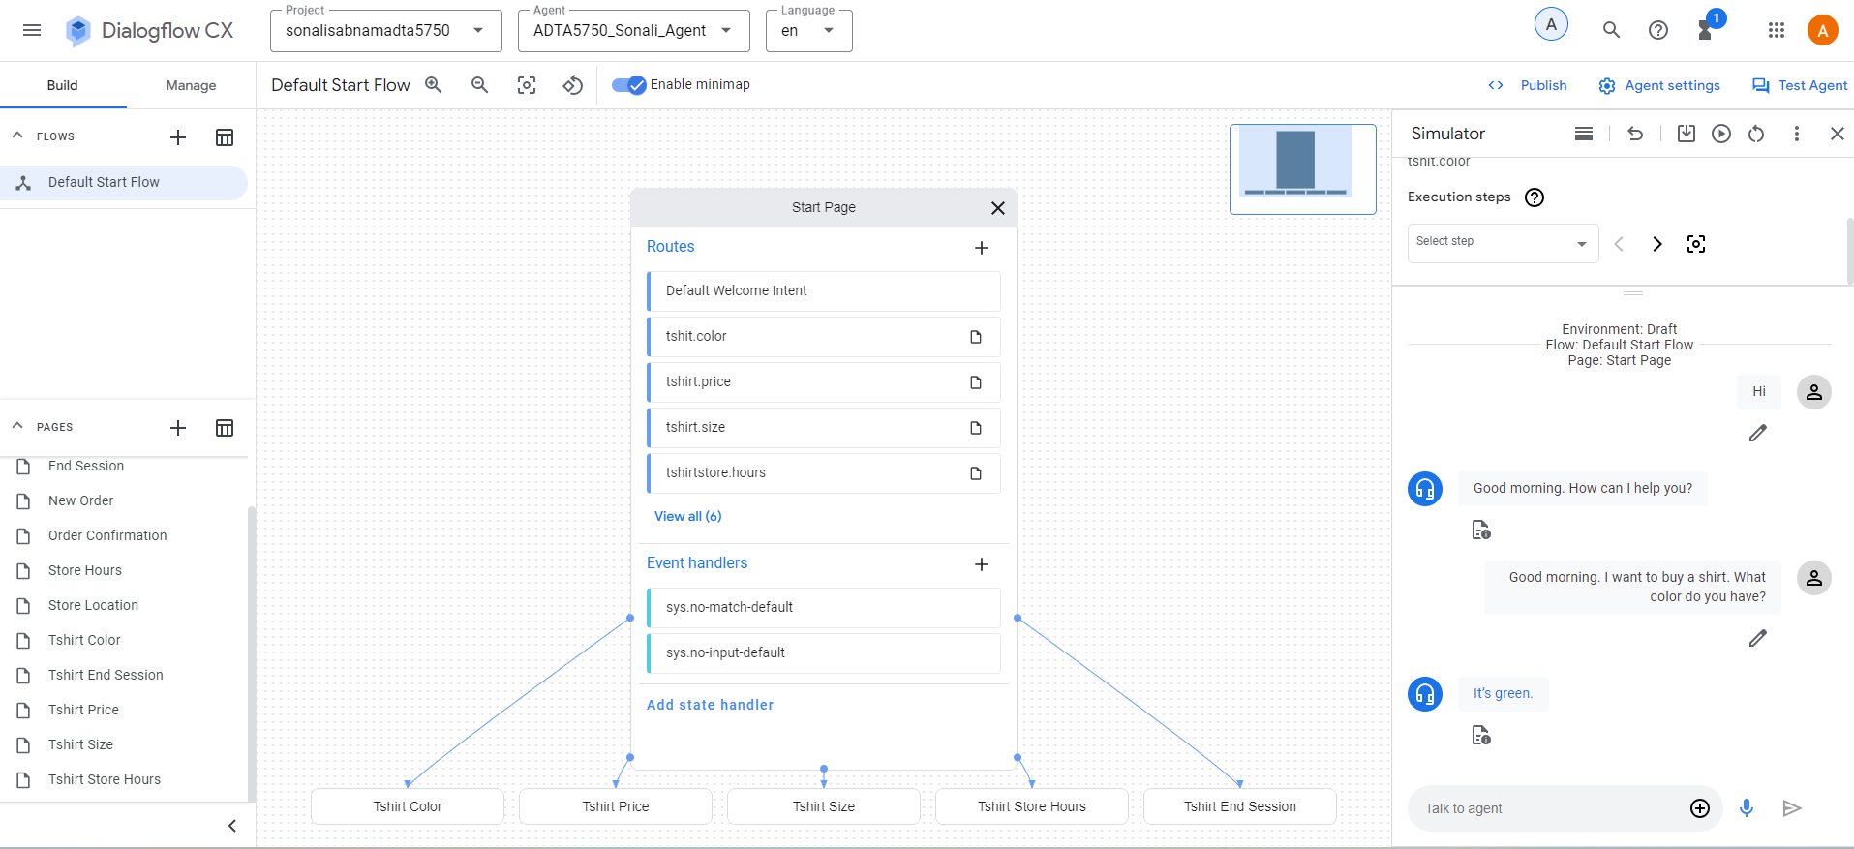
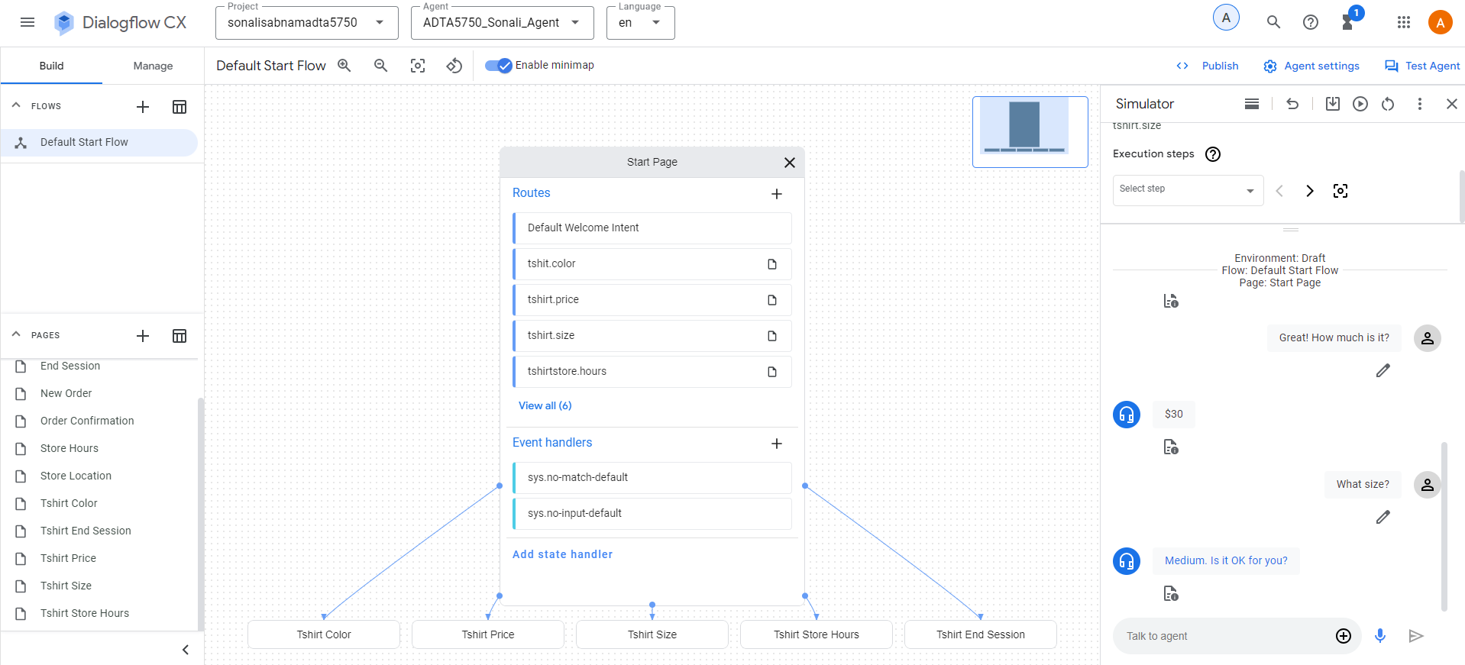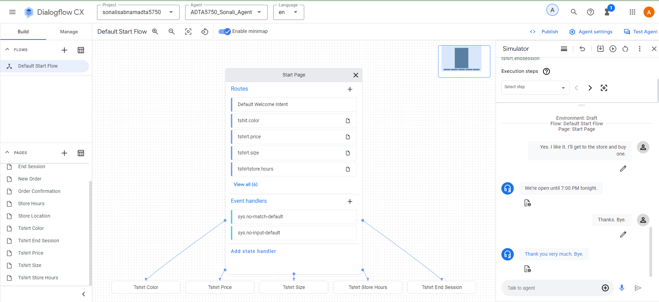

Question 3.3
Based on the conversation design, provide the following pieces of information:
- What conversation session does the design visualize?
Answer: The conversation is between a retail store agent and a customer. The retail store sells medium size tshirt in green color for $30. The customer is inquiring about the availability of the tshirt.
- How many pages? What does each page refer to?
Answer: There are five pages. Each page is tied to an intent with a training phrase and fulfilment criteria. A page can have an entry fulfilment which is invoked once the page gets active. This entity fulfilment has a response to the user.

- How many states? What does each state refer to?
Answer: In my design there are total six steps.
- Start Page: it is the initial state. The conversation begins here.
- Tshirt Color: it is the second state. The customer asks about the color of the tshirt here.
- Tshirt Price: it is the third state. The customer asks about the price of the tshirt here.
- Store Hours: this is the fourth state. The customer shows interest about coming to the store to buy the tshirt.
- End Session: this is the fifth state. Both the customer and Agent say “Bye” and hangup.
- Are there any state handlers? If YES, what are they?
Answer: I am handling the state by providing the agent response in the fulfilment criteria of the page. So for each page I have the fulfilment criteria which handles the state and moves the conversation.
- Are there intents? What are they?
Answer: There are five intents in this conversation which are tied to the pages i.e. each page is tied to an intent.
Intents in the conversation:
- tshirt.color
- tshirt.price
- tshirt.size
- tshirtstore.hours
- tshirt.endsession
- Are there entities? What are they?
Answer: I have used Fulfilment as an entity for each page to handle the state. For every page depending on the current state, I have specified the Fulfilment to continue the conversation or move it to the next state.

